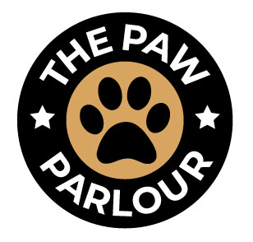

**What​ ​can​ ​happen​ ​to​ ​my​ ​dogs​ ​skin​ ​as​ ​a​ ​result​ ​of​ ​matting?**  
​Matting can make it very difficult to see the skin beneath. As a result, the mat may conceal fleas, or pests, skin irritations, lesions, scabs and other conditions.

**Why​ ​can’t​ ​we​ ​just​ ​bathe​ ​them?​** ​**Or​ ​just​ ​cut​ ​the​ ​mats​ ​out?**  
Bathing a matted pet cannot only prevent the dog from drying properly but cause the matts to become worse. Mats soak up water like a sponge, causing the mats to become tighter, bigger and closer to the skin. Just cutting mats out is not recommended as the skin can become entangled in the matts resulting in an injured pet. The safest way to remove mats close to the skin is by shaving it out close to the skin.

**Why​ ​can’t​ ​we​ ​brush out the mat?**  
​Brushing out the mat can be done if the matting is not too extensive; however, it can be extremely painful and uncomfortable to your pet. With de-matting, you always run the risk of cutting or injuring your pet. Not only do you run the risk of injuring your dog with de-matting, but the grooming process necessary to remove mats from the coat may aggravate your pet’s skin.

**Why​ ​do​ ​most​ ​groomers​ ​end​ ​up​ ​having​ ​to​ ​shave​ ​my​ ​dog?**  
​In some instances, shaving maybe your only option. We have to be able to get under the mat in order to remove it properly. Sometimes, small areas can be spot shaved.  
Spot shaving is where we are able to save the main bulk of body hair but trim a small matted area and blend in with scissor. Sensitive areas will have to be shaved (such as behind the ears, part of the tail, armpits, or under the belly).

**Parental​ ​Consent​ ​to​ ​Remove​ ​Mats/​ ​De-matting**  
Please keep in mind that while I will always do what is safest for your pet, the removal of mats is a time consuming and sometimes dangerous process resulting in skin irritations and in the most severe cases hematomas and cuts/ scrapes.

Due to the amount of matting in my pet’s coat, I agree that all or part of the coat cannot be saved without causing discomfort or harm to my pet. I therefore authorize The Paw Parlour to remove (shave down or spot shave) my pet’s coat.

By my signature below, I release The Paw Parlour from any and all liability for any skin conditions that might be revealed by the removal of the matted coat. I understand that such pre-existing conditions are not the responsibility of The Paw Parlour. Revealed medical conditions may require veterinary care and I will assume financial responsibility of any such expense.

Name

…………………………………………………………………………

Pet Name

…………………………………………………………………………

Signature

………………………………………………………………………….

Date